**ASSIGNMENT – 3**

**TEAM ID : PNT2022TMID49399**

**PROJECT NAME : NEWS TRACKER APPLICATION**

1. *CREATE USER TABLE WITH EMAIL, USERNAME, ROLL NUMBER, PASSWORD*

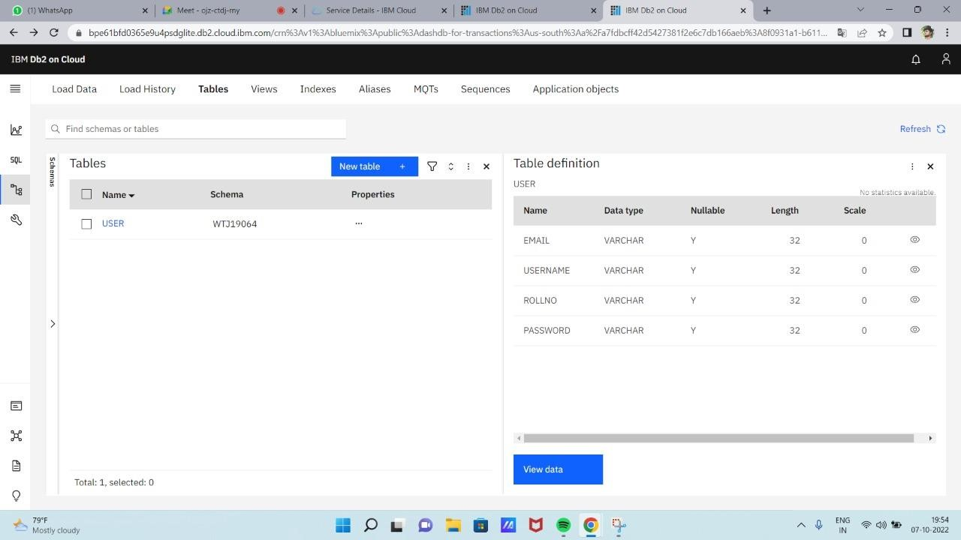

**INSERT QUERY :**

INSERT INTO USER(email,username,rollno,password)

VALUES('kavinag197@gmail.com','Kavin_51','19CS051',1234),

('pradeeep@gmail.com','pradeep84','19CS084',3434),

('dhyanaparna14@gmail.com','Aparna22','19CS022',12356),

('pandidurai@gmail.com','Pandi79','19CS079',9775);

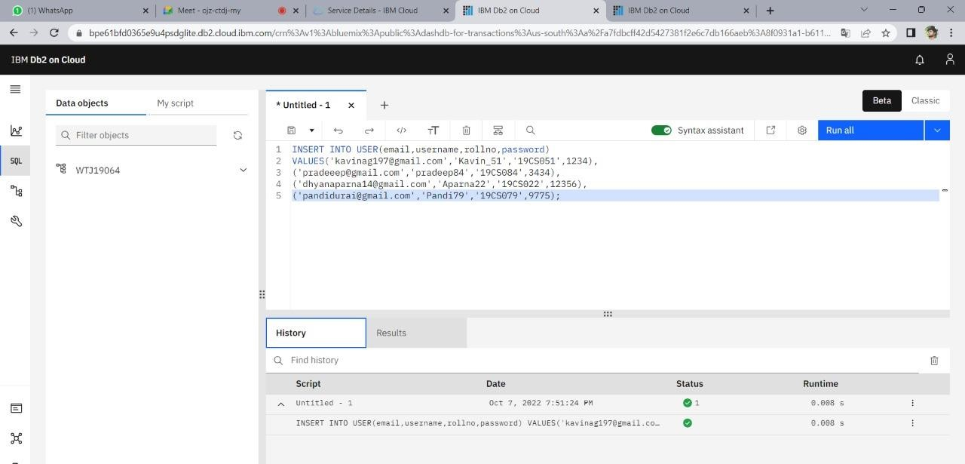

**AFTER INSERTING THE VALUES INTO THE TABLE:**

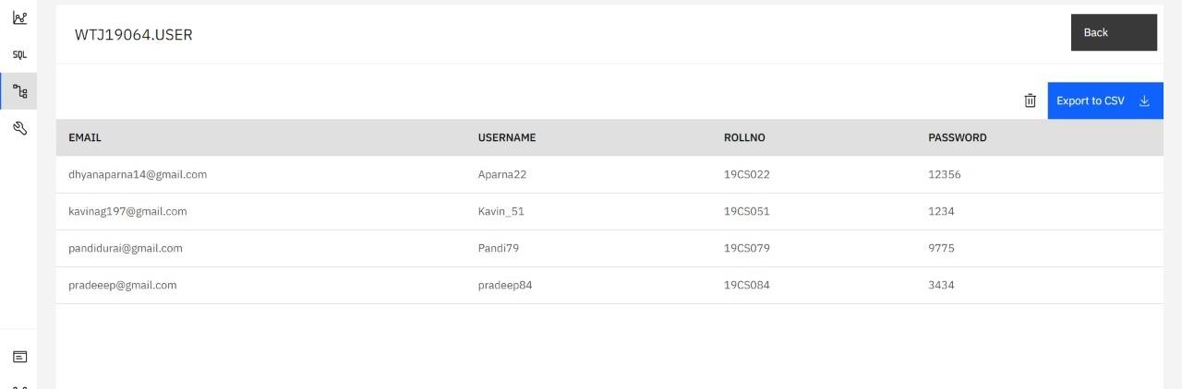

1. *PERFORM UPDATE AND DELETE QUERIES WITH USER TABLE :*

**DELETING QUERY :**

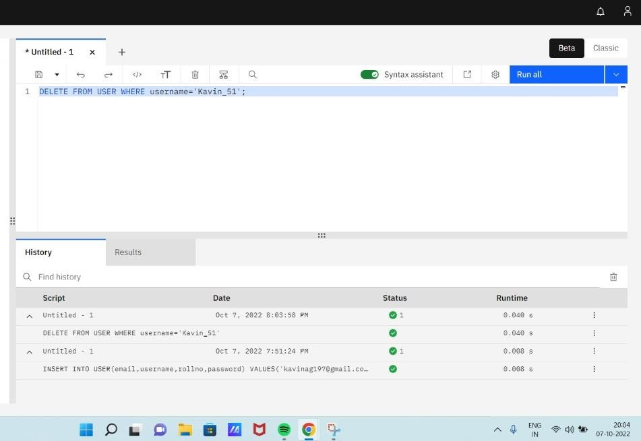DELETE FROM USER WHERE username='Kavin_51';

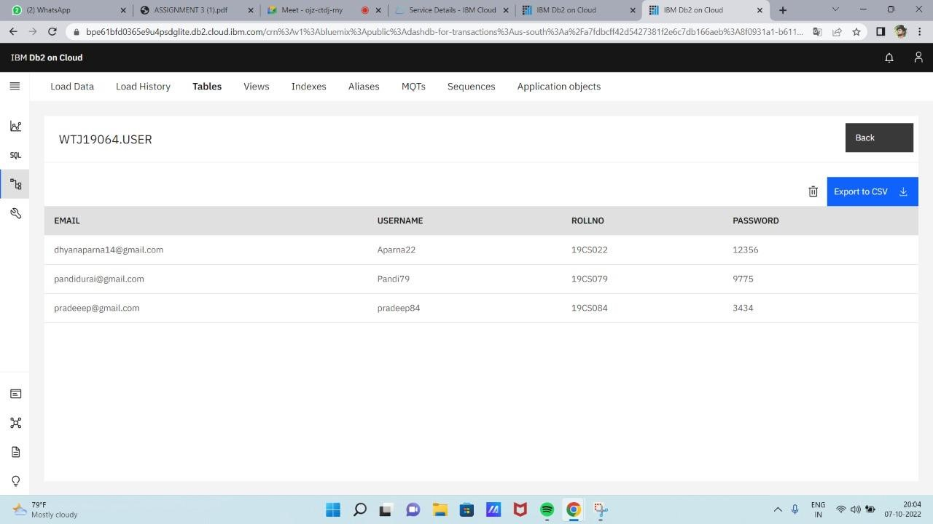

**UPDATING QUERY :**

INSERT INTO USER(email,username,rollno,password)

VALUES('kavinag197@gmail.com','Kavin_51','19CS051',1234);

UPDATE user SET email='pradeeep@gmail.com',password='8484'

WHERE

rollno='19CS084';

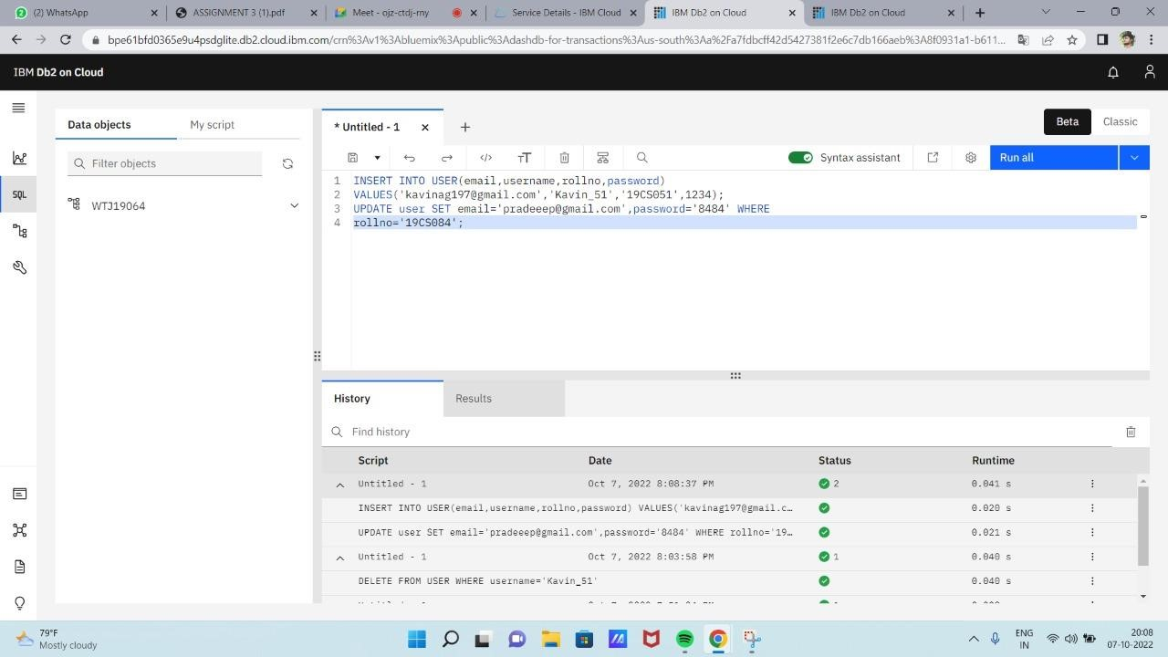

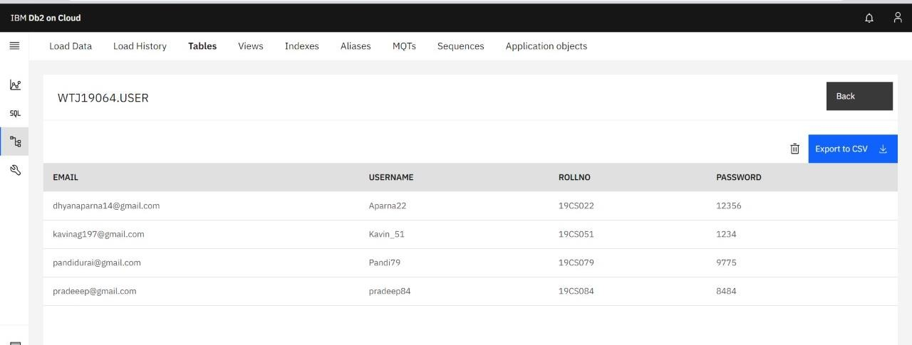

1. *CONNECT PYTHON TO db2:*

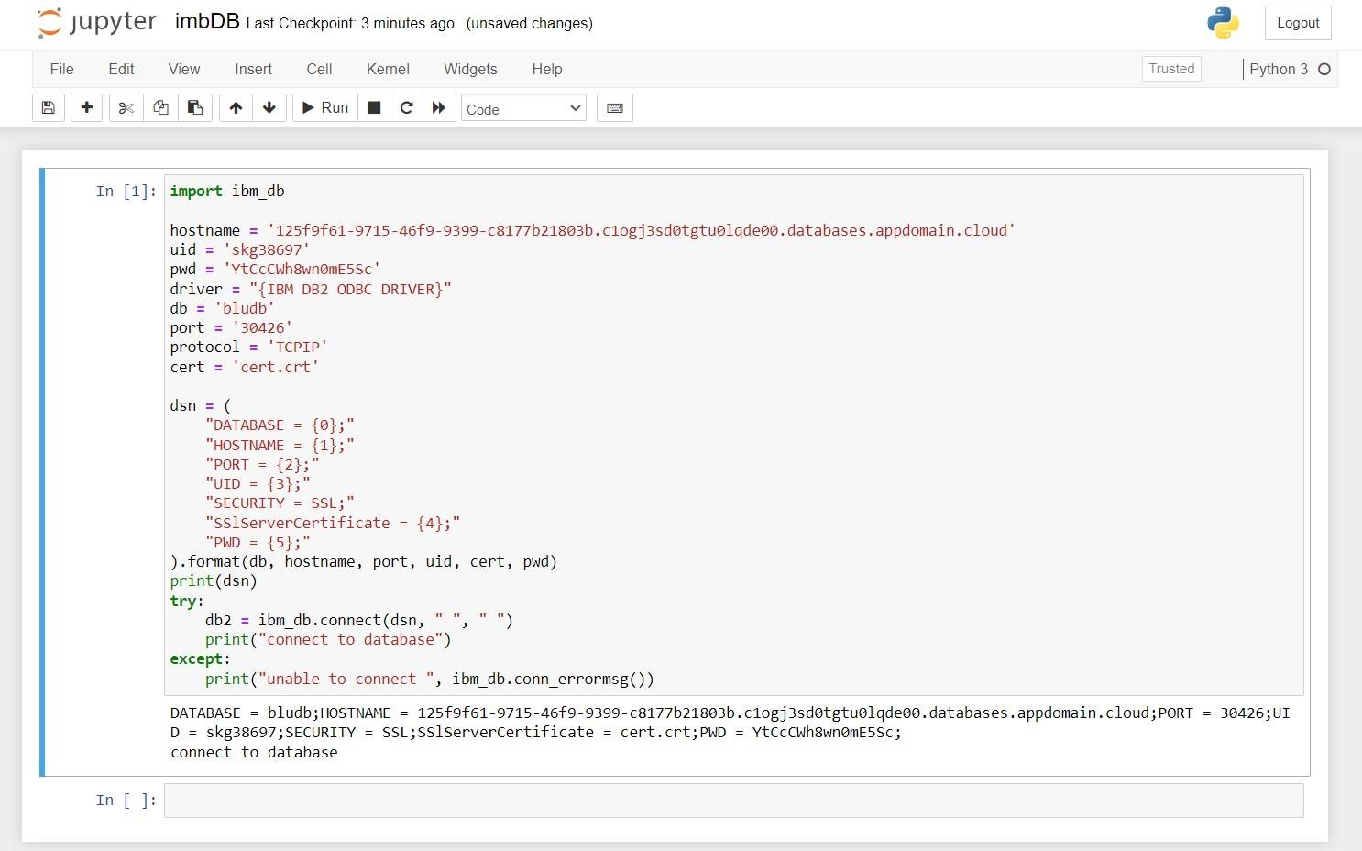

**CODE :**

import ibm_db

hostname = '9938aec0-8105-433e-8bf9-

0fbb7e483086.c1ogj3sd0tgtu0lqde00.databases.appdomain.cloud' uid = 'qfk33398' pwd = 'jnfFMaLIMeTZcout' driver = "{IBM DB2 ODBC DRIVER}"

db = 'bludb' port = '32459'

protocol = 'TCPIP' cert = 'CRT1.crt' dsn = (

"DATABASE = {0};"

"HOSTNAME = {1};"

"PORT = {2};"

"UID = {3};"

"SECURITY = SSL;"

"SSlServerCertificate = {4};"

"PWD = {5};"

).format(db, hostname, port, uid, cert, pwd) print(dsn) try:

db2 = ibm_db.connect(dsn, " ", " ") print("connect to database") except:

print("unable to connect ", ibm_db.conn_errormsg())

*4.about.html*

<!DOCTYPE html>

<html lang="en">

<head>

<meta charset="utf-8">

<meta name="viewport" content="width=device-width,initial-scale=1"> <title>About Page</title>

<link href="[https://cdn.jsdelivr.net/npm/bootstrap@5.0.0-](https://cdn.jsdelivr.net/npm/bootstrap%405.0.0-) beta2/dist/css/bootstrap.min.css" rel="stylesheet">

</head>

<body>

<nav class="navbar navbar-expand-lg bg-light" style="background-color:

#b5dbf7;">

<!-- Navbar content -->

<div class="container-fluid">

<div class="collapse navbar-collapse" id="navbarNavAltMarkup">

<div class="navbar-nav">

<a class="nav-link " href="home.html">Home</a>

<a class="nav-link active" aria-current="page"

href="#">About</a>

<a class="nav-link" href="signin.html">Sign In</a>

<a class="nav-link" href="signup.html">Sign up</a> </div>

</div>

</div>

</nav>

<br><br>

<footer>

International Business Machines Corporation is an American multinational technology corporation headquartered in Armonk, New York, with operations in over 171 countries.

</footer>

</body>

</html>

# Home.html

<!DOCTYPE html>

<html lang="en">

<head>

<meta charset="utf-8">

<meta name="viewport" content="width=device-width,initial-scale=1"> <title>Home Page</title>

<link href="[https://cdn.jsdelivr.net/npm/bootstrap@5.0.0-](https://cdn.jsdelivr.net/npm/bootstrap%405.0.0-) beta2/dist/css/bootstrap.min.css" rel="stylesheet"> </head>

<body>

<nav class="navbar navbar-expand-lg bg-light" style="background-color:

#e3f2fd;">

<!-- Navbar content -->

<div class="container-fluid">

<div class="collapse navbar-collapse" id="navbarNavAltMarkup">

<div class="navbar-nav">

<a class="nav-link active" aria-current="page"

href="#">Home</a>

<a class="nav-link" href="about.html">About</a>

<a class="nav-link" href="signin.html">SignIn</a>

<a class="nav-link" href="signup.html">SignUp</a> </div>

</div>

</div>

</nav>

<br><br>

<div>

<h4>

<b>Welcome to IBM!!!</B>

</h4>

</div>

</body>

</html>

# Signin.html

<!DOCTYPE html>

<html lang="en">

<head>

<meta charset="utf-8">

<meta name="viewport" content="width=device-width,initial-scale=1"> <title>SignIn</title>

<link href=["https://cdn.jsdelivr.net/npm/bootstrap@5.0.0-](https://cdn.jsdelivr.net/npm/bootstrap%405.0.0-) beta2/dist/css/bootstrap.min.css" rel="stylesheet"> </head>

<body>

<nav class="navbar navbar-expand-lg bg-light" style="background-color:

#e3f2fd;">

<!-- Navbar content -->

<div class="container-fluid">

<div class="collapse navbar-collapse" id="navbarNavAltMarkup">

<div class="navbar-nav">

<a class="nav-link " href="home.html">Home</a>

<a class="nav-link" href="about.html">About</a> <a class="nav-link active" aria-current="page"

href="#">SignIn</a>

<a class="nav-link" href="signup.html">SignUp</a> </div>

</div>

</div>

</nav>

<div class="text-center my-5" style="background-image:

url('https://png.pngtree.com/thumb_back/fh260/background/20200714/pngtree- modern-double-color-futuristic-neon-background-image_351866.jpg'); background-repeat: no-repeat;

background-size: cover;">

<section class="h-100">

<div class="container h-100">

<div class="row justify-content-sm-center h-100">

<div class="col-xxl-4 col-xl-5 col-lg-5 col-md-7 col-sm- 9">

<div class="text-center my-5"></div>

<div class="card shadow-lg">

<div class="card-body p-5">

<h1 class="fs-4 card-title fw-bold mb-

4">Login</h1>

<form method="POST" class="needs-validation"

novalidate="" autocomplete="off">

<div class="mb-3">

<label class="mb-2 text-muted"

for="email">E-Mail Address</label>

<input id="email" type="email"

class="form-control" name="email" value="" required autofocus>

<div class="invalid-feedback">

Email is invalid

</div>

</div>

<div class="mb-3">

<div class="mb-2 w-100">

<label class="text-muted" for="password">Password</label>

<a href="forgot.html"

class="float-end">

Forgot Password?

</a>

</div>

<input id="password" type="password"

class="form-control" name="password"

|  |  |
| --- | --- |
| name="remember" id="remember"    check-label">Remember Me</label>    primary ms-auto"> | required>  <div class="invalid-feedback">  Password is required  </div>  </div>    <div class="d-flex align-items-center">  <div class="form-check">  <input type="checkbox"    class="form-check-input">  <label for="remember" class="form-    </div>  <button type="submit" class="btn btn- |

Login

</button>

</div>

</form>

</div>

<div class="card-footer py-3 border-0">

<div class="text-center"> Don't have an account? <a

href="signup.html" class="text-dark">Create

One</a>

</div>

</div>

</div>

</div>

</div>

</div>

</section>

</div>

</body>

</html>

# Signup.html

<!DOCTYPE html>

<html lang="en">

<head>

<meta charset="utf-8">

<meta name="viewport" content="width=device-width,initial-scale=1"> <title>SignUp</title>

<link href="[https://cdn.jsdelivr.net/npm/bootstrap@5.0.0-](https://cdn.jsdelivr.net/npm/bootstrap%405.0.0-) beta2/dist/css/bootstrap.min.css" rel="stylesheet"> </head>

<body>

<nav class="navbar navbar-expand-lg bg-light" style="background-color:

#e3f2fd;">

<!-- Navbar content -->

<div class="container-fluid">

<div class="collapse navbar-collapse" id="navbarNavAltMarkup">

<div class="navbar-nav">

<a class="nav-link " href="home.html">Home</a>

<a class="nav-link" href="about.html">About</a>

<a class="nav-link" href="signin.html">SignIn</a> <a class="nav-link active" aria-current="page"

href="#">SignUp</a>

</div>

</div>

</div>

</nav>

<div class="text-center my-5" style="background-image:

url('https://png.pngtree.com/thumb_back/fh260/background/20200714/pngtree- modern-double-color-futuristic-neon-background-image_351866.jpg'); background-repeat: no-repeat; background-size: cover;">

<section class="h-100">

<div class="container h-100">

<div class="row justify-content-sm-center h-100">

|  |  |
| --- | --- |
| <div class="col-xxl-4 col-xl-5 col-lg-5 col-md-7 col-sm- | |
| 9">            4">Register</h1> | <div class="text-center my-5"></div>  <div class="card shadow-lg">  <div class="card-body p-5">  <h1 class="fs-4 card-title fw-bold mb- |

<form method="POST" class="needs-validation"

novalidate="" autocomplete="off">

<div class="mb-3">

<label class="mb-2 text-muted" for="name">Name</label>

<input id="name" type="text"

class="form-control" name="name" value="" required autofocus>

<div class="invalid-feedback">

Name is required

</div>

</div>

<div class="mb-3">

<label class="mb-2 text-muted"

for="email">E-Mail Address</label>

<input id="email" type="email"

class="form-control" name="email" value="" required>

<div class="invalid-feedback">

Email is invalid

</div>

</div>

<div class="mb-3">

|  |  |
| --- | --- |
| for="password">Password</label> | <label class="mb-2 text-muted"  <input id="password" type="password" |
| class="form-control" name="password" |  |

required>

<div class="invalid-feedback"> Password is required

</div>

</div>

|  |  |  |
| --- | --- | --- |
|  |  |  |
| terms and condition.          primary ms-auto"> |  | <p class="form-text text-muted mb-3"> By registering you agree with our  </p>  <div class="align-items-center d-flex">  <button type="submit" class="btn btn-  Register  </button>  </div>  </form> |
| </div>  <div class="card-footer py-3 border-0"> <div class="text-center"> | |

Already have an account?

<a href="signin.html" class="text-dark">Login</a>

</div>

</div>

</div>

</div>

</div>

</div>

</section> </div>

</body>

</html>

**app.py**

from flask import Flask, render_template app = Flask(__name )

@app.route("/") @app.route("/hom e") def home():

return render_template("home.html")

@app.route("/abou t") def about():

return render_template("about.html")

@app.route("/signi n") def signin():

return render_template("signin.html")

@app.route("/signu p") def signup(): return render_template("signup.html")